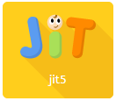
JIT5 (Just 2 Easy - Infant Toolkit)
8 options: WRITE – PAINT – TURTLE – CHART – PICTOGRAM – ANIMATE - BRANCH MIX
WRITE
Title
Background – Open – Save – Publish – Print

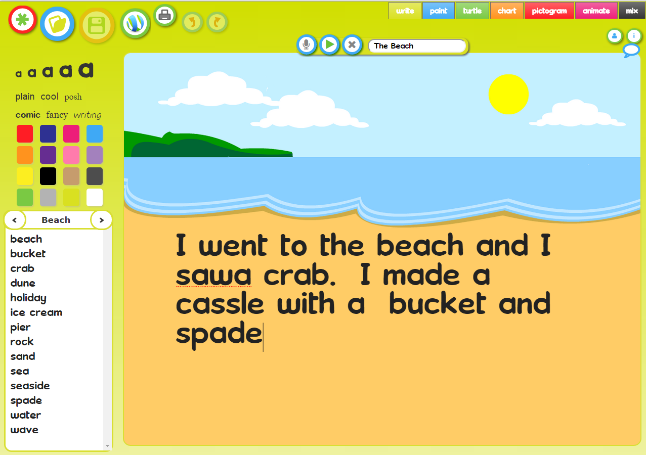
PAINT
Type text
Word Banks
Undo Redo text
Read text
Record 10 secs
Text size
Fonts
Colours
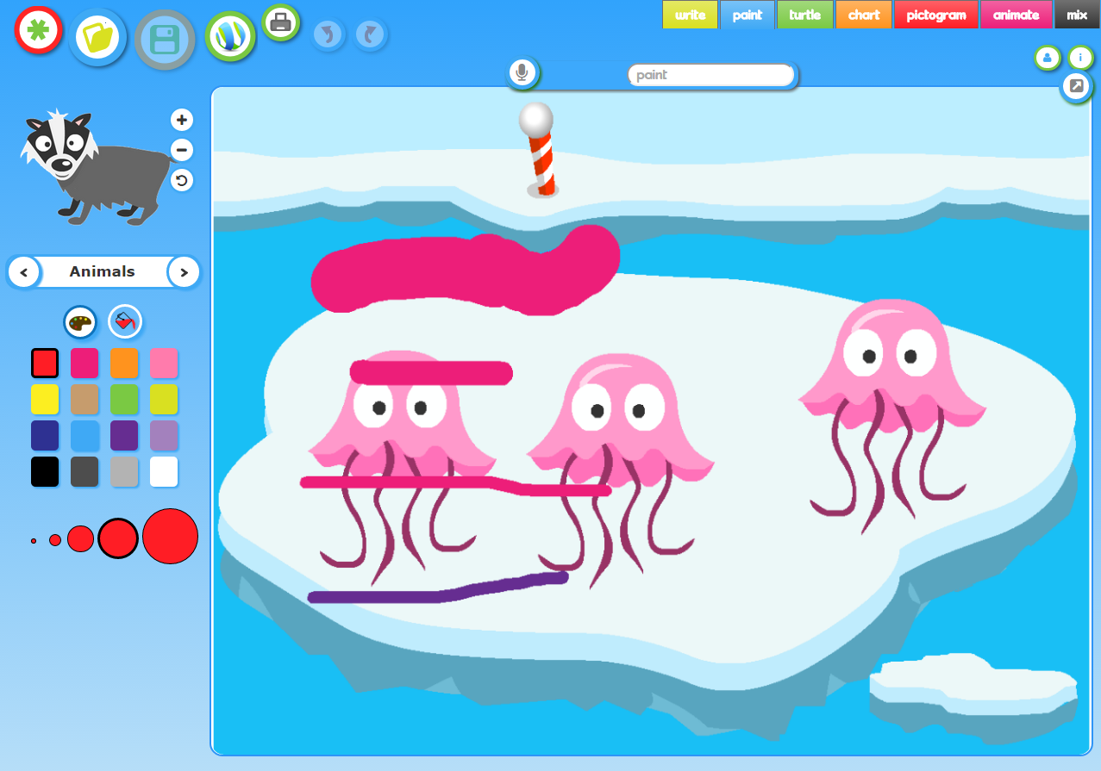
Save as image
Colours
Size
Paint / Fill tool
Record sound
Title
Stamps
Banks
Bigger
Smaller
Flip L/R

TURTLE
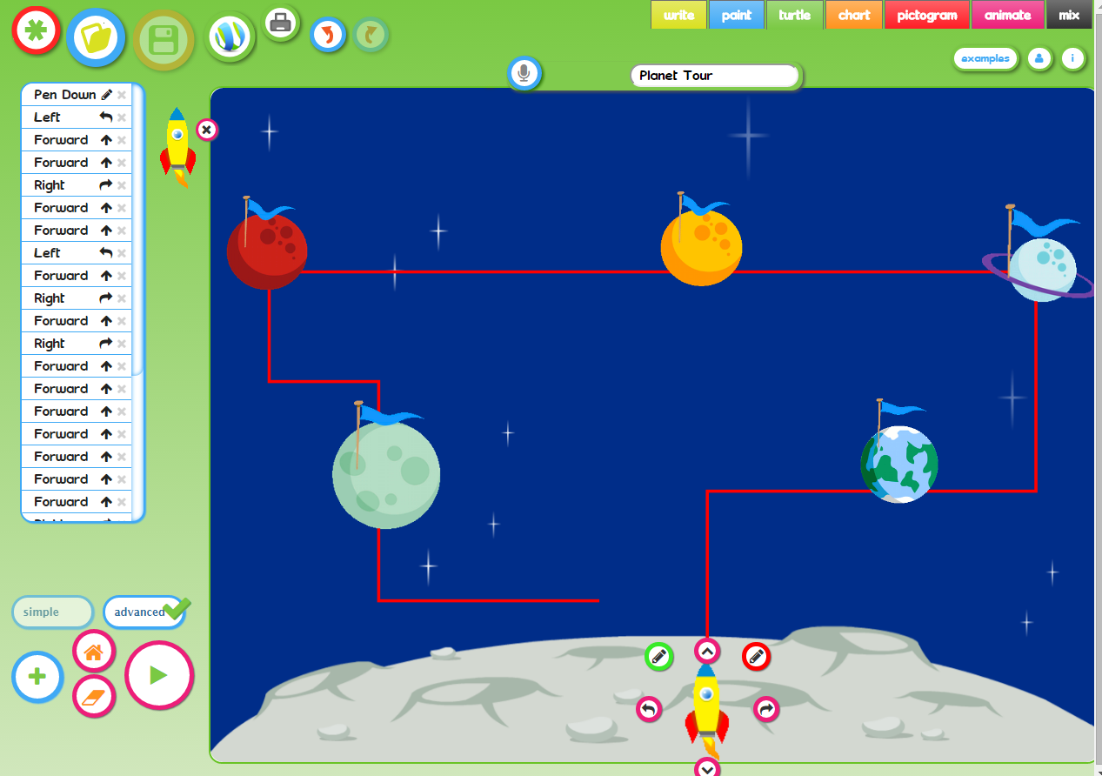
Sprite and buttons:
Forward / Back
Rotate left / right
Pen down / up
Advanced: sprite doesn’t move until you Run the Program
Pen Down = Draw a line
Algorithm = list of commands
Move / delete
Simple: sprite moves immediately
Run the program
Erase commands
Add a sprite
CHART
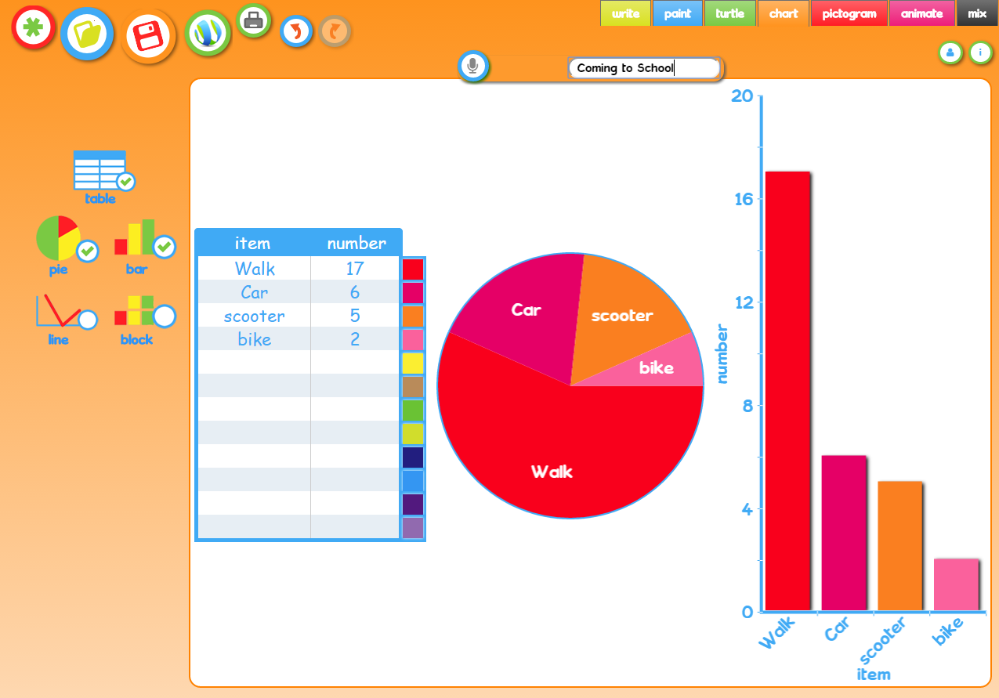
Record sound
Title
Type your data here
Data options

PICTOGRAM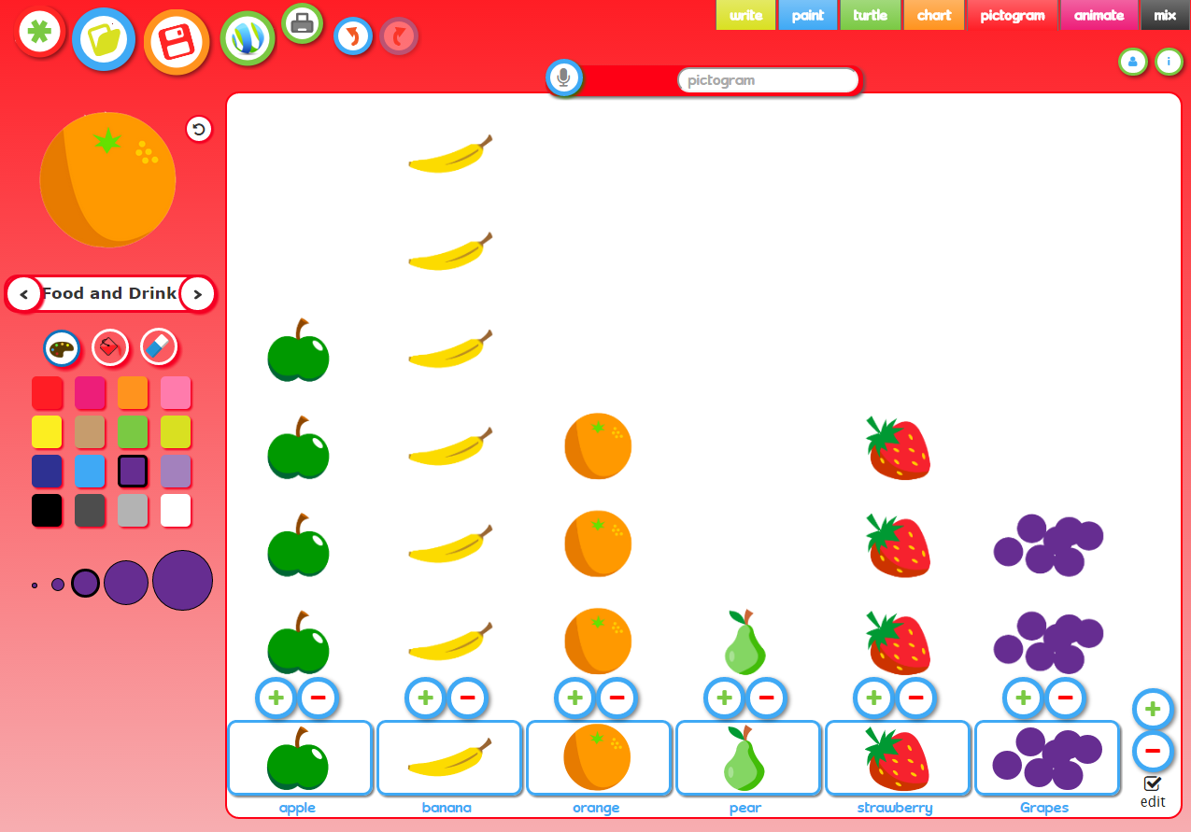
Click to
add / remove
Add another item
(Use paint tools)
ANIMATE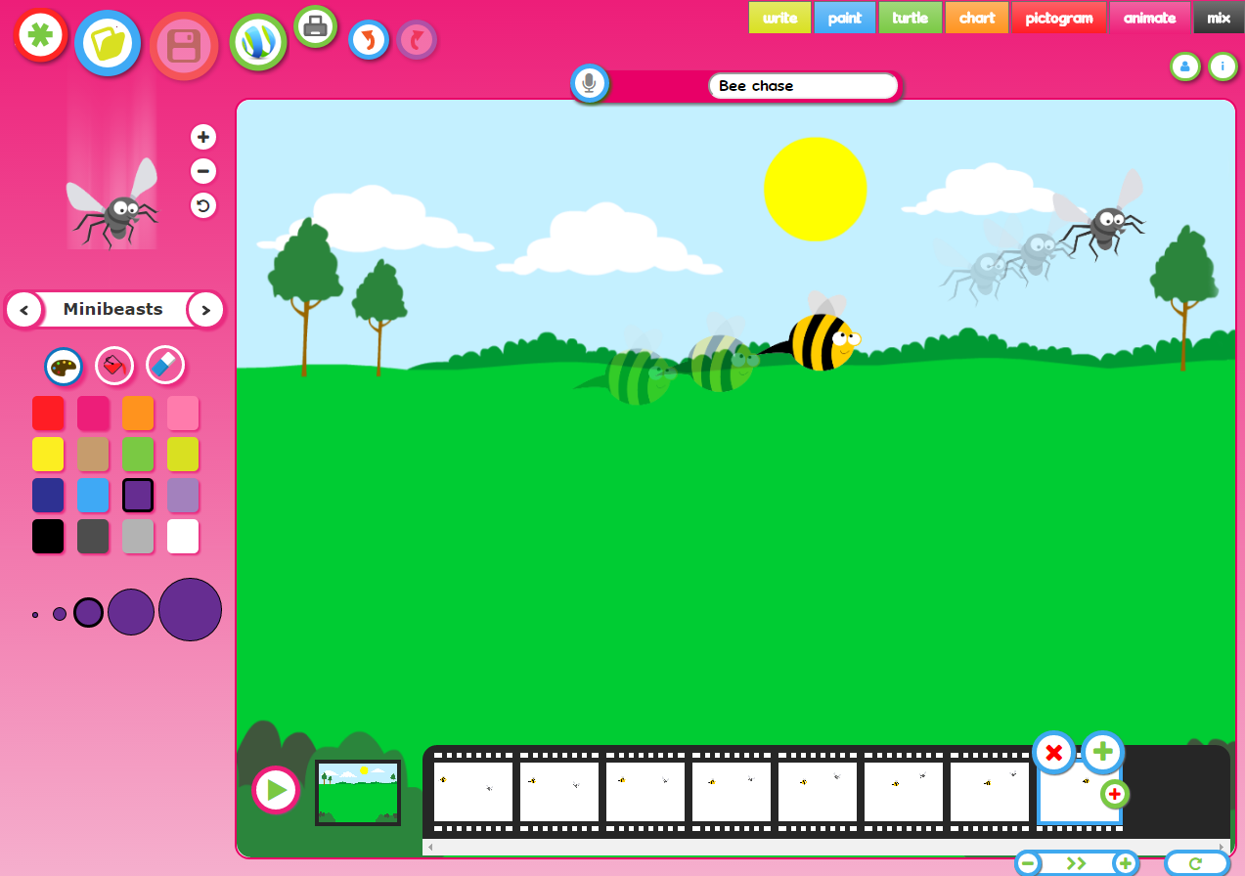
Click next frame and position stamp about 1-2 cm along
Play / Stop
Edit Background
Copy frame
Delete / add frame
Complete all frames for ONE character before returning to first frame & adding a second character, frame by frame
Speed
Loop / To & from
Choose a character stamp and position on first “frame”
Repeat for more frames


BRANCH
Choose a backgrounf, if any.
Choose a range of items (images) either from the library or using a safe image search or using just words.
Examples: animals, musical instruments, clothes, faces, vehicles, etc
When you have selected your group of items, you need to think of a “Yes / No” question that will divide them in to 2 groups . Eg: Animals: Can it fly? Instruments: “Does the instrument have strings?”
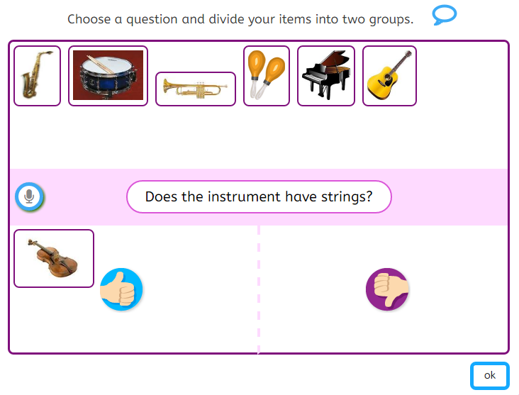
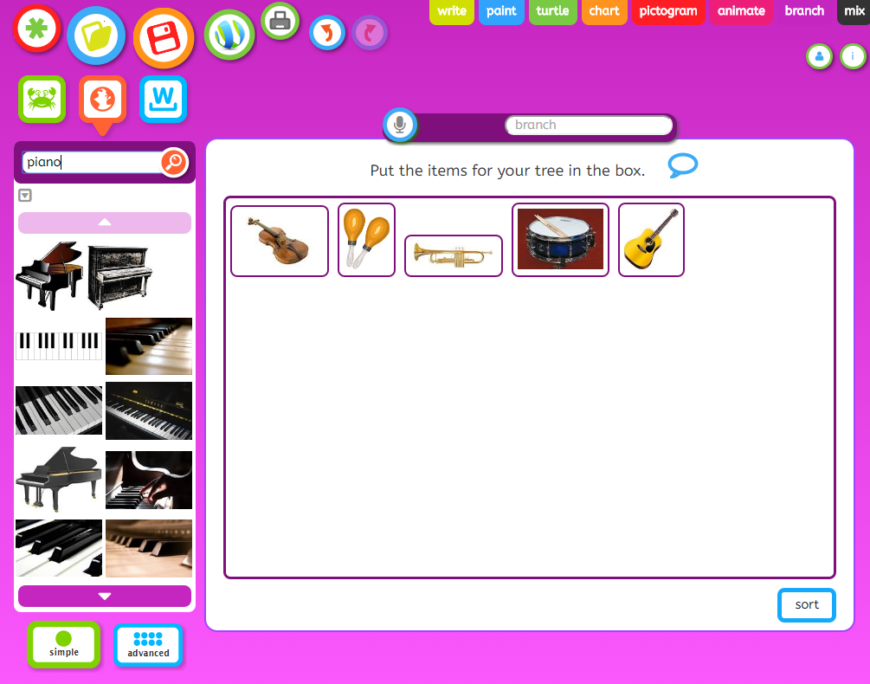
Advanced mode allows you to type extra information:
Title & Description

Drag all your items in the yes / no boxes to indicate the response to this question, and continue with each sub-group, thinking up further questions until every object has been identified.
You can then “play” the Branch database or “Tree”, by thinking of an item and answering the questions until your item is identified OR you add another object to the branching database.
Get the children to use each other’s tree. Discuss what makes a good question and whether it matters which question is used first

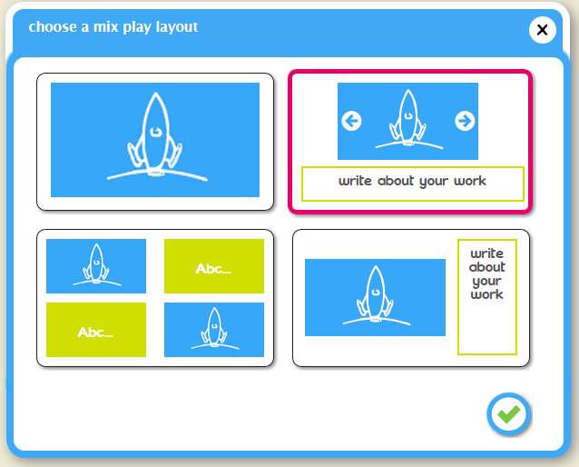
MIX
You can create a page that combines write with another mode: paint / turtle / chart / pictogram / animation
Choose preferred extra mode
Choose preferred layout
You can add more pages with different layouts and modes. Remember to add a title and sound recording.
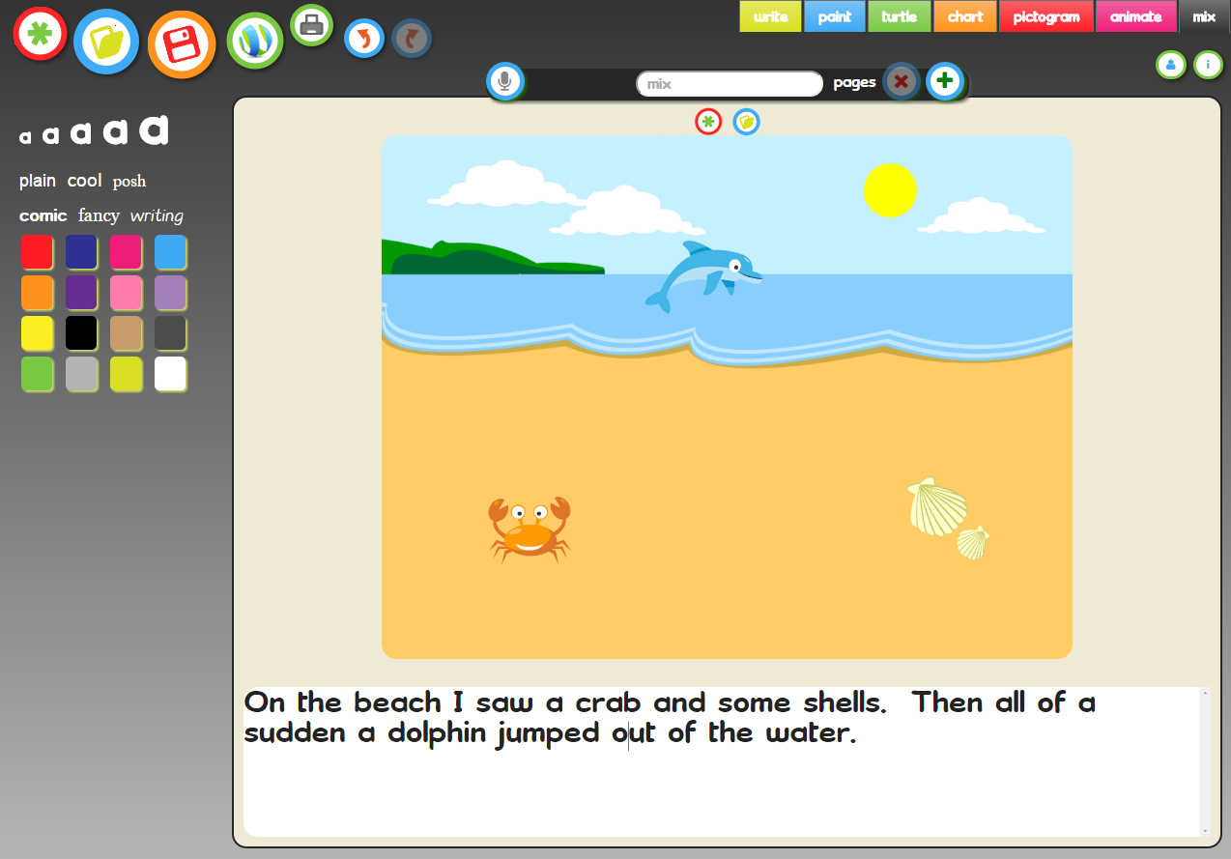
Combining Write with Paint.
This panel changes to show the tools for write or paint mode when you click here
Next page.
Previous page.
Delete / Add page.

REMEMBER: ANY work done in any of the JIT tools can be published to your school’s blog site using the Publish button. This puts the child’s work in to a “pending” area awaiting a decision (to “Publish” or “Bin”), from a teacher in the Dashboard.
Please do DO NOT let children use the software while logged in as a teacher.
When logged in as a teacher work goes LIVE to the blogsite immediately the Publish button is clicked!

